***Healthcare Capstone Project – Tableau Dashboard***

Healthcare Capstone Project HTML file - file:///F:/healthcare%20project/HealthCare%20-%20Diabetes%20Prediction.%20html.html

Tableau Public Link - <https://public.tableau.com/profile/asit.kumar.dubey#!/>

GitHub profile - <https://github.com/Asit-1121130118/practice-projects> for code and dataset can be downloaded from here.

1. Dashboard 1 - <https://public.tableau.com/profile/asit.kumar.dubey#!/vizhome/HealthcareCapstoneprojectDashboard1/HealthcareCapstoneProject-1>

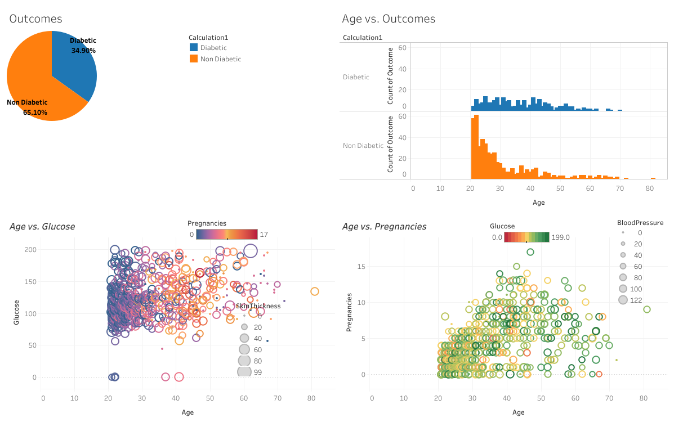

1. Dashboard 2 - <https://public.tableau.com/profile/asit.kumar.dubey#!/vizhome/HealthcareCapstoneprojectDashboard2/Dashboard2>

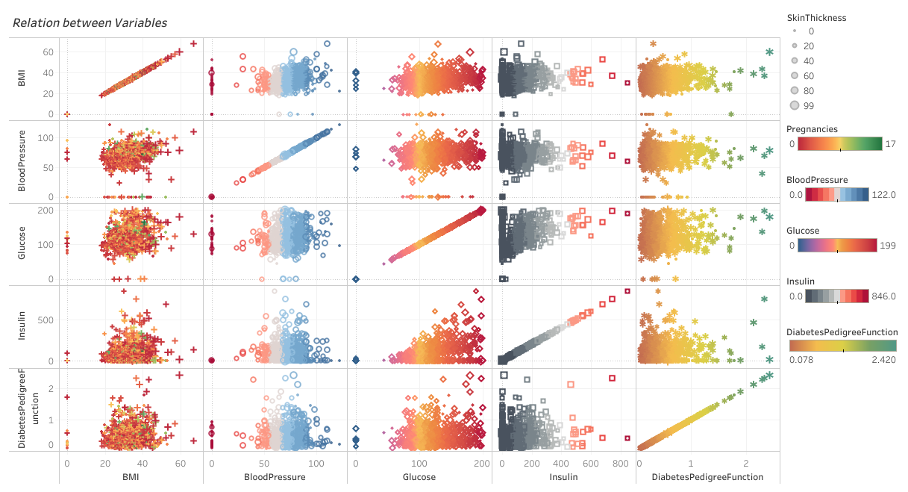

1. Dashboard 3 - <https://public.tableau.com/profile/asit.kumar.dubey#!/vizhome/HealthcareCapstoneprojectDashboard3/Dashboard3>

